Abstract - In this paper, we dive into a thorough examination of machine learning algorithms aimed at predicting medical insurance costs. By utilizing a real-world dataset, we investigate three different regression techniques: Linear Regression, Random Forest Regressor, and Gradient Boosting Regressor. Our study covers essential data preprocessing methods, the training of models, and performance assessment through metrics like Root Mean Squared Error (RMSE) and R-squared (R²). We also take a closer look at the computational complexity associated with each method. Our findings reveal that the Gradient Boosting Regressor stands out with the best performance, proving to be a strong candidate for predicting healthcare expenses.
Predictive Modeling of Medical Insurance Costs Using Machine Learning Techniques
Carlos Hidalgo Escobar, Universidad Autónoma del Occidente, Santiago de Cali carlos.hidalgo@uao.edu.co
I. INTRODUCTION
Getting a handle on medical insurance charges is super important for both insurance companies and healthcare providers. There are a bunch of factors that influence premiums, like age, health status, lifestyle choices, and where you live. Traditional actuarial methods often miss the intricate relationships between these variables, which can lead to less accurate estimations. That's where machine learning (ML) comes in it’s a powerful tool that can help us model these complex interactions, leading to better predictions and a clearer understanding of what really matters. This research is all about applying and comparing different ML algorithms to predict individual insurance charges based on personal and demographic information [1].

II. DATASET DESCRIPTION AND GENERATION
The dataset used in this study originates from a publicly available source on Kaggle [2]. It consists of 1,338 observations with the following features:
- Age: Integer value representing the age of the primary beneficiary.
- Sex: Categorical variable indicating gender (male or female).
- BMI: Body Mass Index, a measure of body fat.
- Children: Number of children covered by the insurance plan.
- Smoker: Binary categorical variable (yes/no).
- Region: Categorical variable indicating the residential region in the US.
- Charges: Continuous variable indicating the individual medical insurance cost (target variable).
The dataset is realistic and sufficiently complex to test machine learning algorithms for regression tasks. No missing values are present, allowing for straightforward preprocessing and modeling.
III. PROBLEM DESCRIPTION
This task revolves around a supervised machine learning regression problem. The goal here is to predict the target variable, which is the insurance cost known as charges, using various input features. Essentially, we’re looking to build a model that understands how different input variables—like age, BMI, and smoking status—interact with one another to influence this continuous output variable. The challenge lies in the potential nonlinear relationships between these features and how categorical variables can also play a role.
IV. DATA PREPROCESSING TECHNIQUES
Three distinct preprocessing methodologies were employed:
1. Standardizing Numerical Features: To standardize our numerical features like age, BMI, and children, we used StandardScaler to scale the columns based on the mean and standard deviation; this allowed all features to uniformly contribute in a consistent manner to the model.
2. One-Hot Encoding to encode Categorical Features: Categorical variables like sex, smoker, and region were encoded as numerical variables allowing our models to integrate and handle categorical non-numeric data with ease, through OneHotEncoder.
3. Pipeline Processing: Each preprocessing step was combined together for each dataset through the ColumnTransformer and integrated into machine learning pipelines. This step-by-step modular approach offered us readable and reproducible processes during model training and hyper-parameter tuning.
Overall, our preprocessing strategies were comprehensive enough to standardize and suitably format the data for the various machine learning models to remove as much bias as possible while promoting model convergence and training.
V. MODEL TRAINING, EVALUATION, AND COMPLEXITY ANALYSIS
We took a close look at three different regression models: Linear Regression, Random Forest, and Gradient Boosting. Each of these models was set up using pipelines that included preprocessing steps.

To fine-tune the models, we used GridSearchCV with 5-fold cross-validation, focusing on neg_mean_squared_error as our scoring metric. For the Random Forest model, we adjusted parameters like n_estimators and max_depth, while for Gradient Boosting, we fine-tuned n_estimators, learning_rate, and max_depth. These tweaks were essential in optimizing the model's complexity and keeping overfitting at bay.
Detect AI-generated content and transform it into something that feels more human with our AI Content Detector. Just paste your text, and in a matter of seconds, you'll receive accurate, relatable results!
Here’s the text we’re looking at:
- Linear Regression acted as our starting point. It struck a decent balance between bias and variance, but it had a tough time picking up on the nonlinear patterns in the data, which showed in its somewhat lower performance scores.
- The Random Forest Regressor took things up a notch compared to the baseline. It managed feature interactions well and cut down on variance by averaging, resulting in solid accuracy and stability, though it did demand a bit more computational power.
- The Gradient Boosting Regressor came out on top overall. By methodically correcting prediction errors and allowing for precise adjustments through learning rate and depth, it effectively minimized both bias and variance, outperforming the other models.
We assessed the models using five different metrics: RMSE, R², MAE, MedAE, and MAPE. Gradient Boosting excelled in all of them, showcasing its superior predictive capabilities.
TABLE 1
COMPARISON OF MODEL PERFORMANCE METRICS (RMSE, MAE, R², ETC.)

Model | RMSE | R² | MAE | MedAE | MAPE (%)
Linear Regression | 5796.28 | 0.7836 | 4181.19 | 2695.14 | 46.89
Random Forest | 4591.93 | 0.8642 | 2522.79 | 1197.37 | 29.73
Gradient Boosting | 4303.06 | 0.8807 | 2457.27 | 1636.15 | 32.21
Conclusion:
- Best RMSE: Gradient Boosting
- Best MAE: Gradient Boosting
- Best MedAE: Random Forest
- Best MAPE: Random Forest
- Best R² Score: Gradient Boosting
Most Outstanding Model Overall: Gradient Boosting
We plotted learning curves for each model to evaluate how they train and generalize.
For Linear Regression, we observed a steady and parallel relationship between the training and validation error curves. This suggests that the model maintains both low variance and low bias. Such behavior is common for simpler models dealing with moderately complex data, indicating that Linear Regression has managed to capture a reasonable approximation of the underlying relationships, even though it struggles with more complex nonlinear patterns.
After fine-tuning the hyperparameters, both Random Forest and Gradient Boosting showed convergence between their training and validation scores, which means there was minimal overfitting. Initially, Random Forest had a larger gap, but this was narrowed by limiting the depth of the trees. On the other hand, Gradient Boosting displayed a smoother and more consistent improvement across the training samples, showcasing its iterative boosting nature and its ability to progressively refine errors.
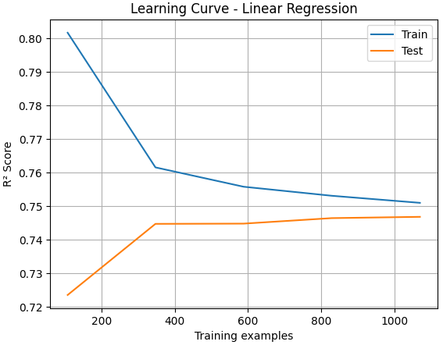
Fig 1. Learning curves of Linear Regression
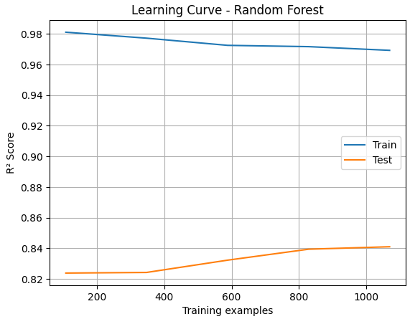
Fig 2. Learning curves of Random Forest
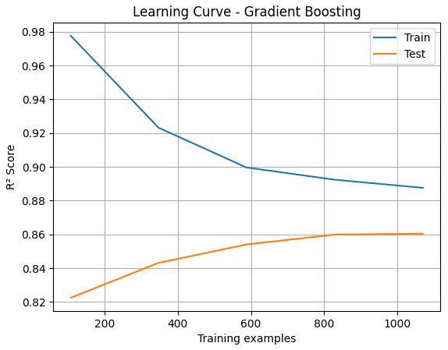
Fig 3. Learning curves of Gradient Boosting
Residual analysis was used to validate the assumptions of regression and assess model fit. Gradient Boosting demonstrated residuals that were more symmetrically distributed around zero with less spread, indicating that it captured the underlying distribution of insurance charges more effectively than the other models. This consistency across prediction intervals further confirms its robustness.

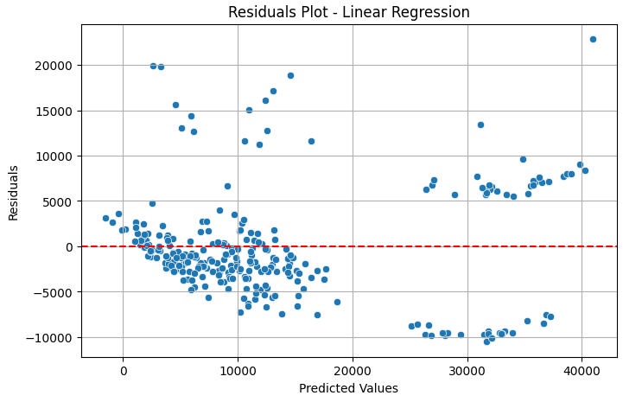
Fig 4. Residual plots of Linear Regression
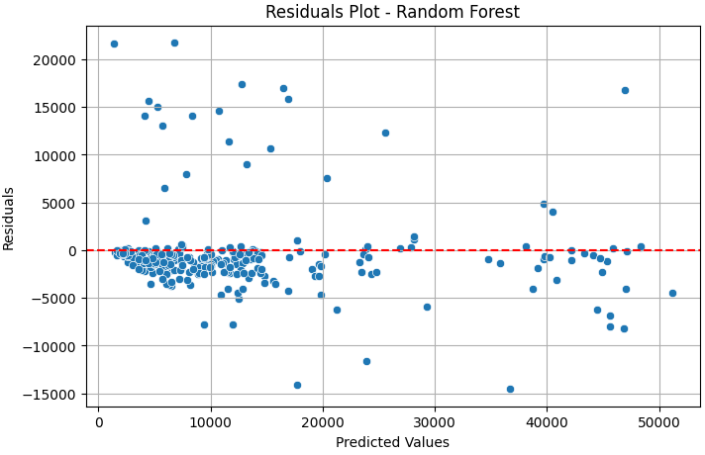
Fig 5. Residual plots of Random Forest

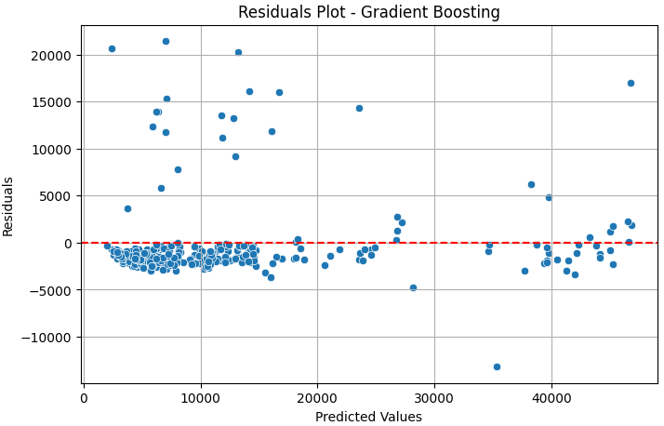
Fig 6. Residual plots of Gradient Boosting
VI. RELATED WORK
Recent studies have explored machine learning methods for cost prediction in healthcare:
- Zou et al. [3] developed a hybrid model combining Gaussian Bayesian networks with regression algorithms to improve medical cost prediction, showing significant improvements over single-algorithm models.
- Orji and Ukwandu [4] applied explainable ML models (e.g., SHAP with XGBoost and Random Forest) for insurance cost estimation, finding XGBoost to have the highest predictive power.
These studies reinforce the viability of ensemble learning methods for healthcare analytics.
VII. FUTURE WORK
While the results yielded from the machine learning models, we applied showed promise, there are several improvements that can be imagined in future work. First, using a larger dataset with more recent or diverse demographics could help enhance generalization. Second, by considering other features such as chronic conditions, lifestyle habits, or regional prices for healthcare might yield even more complex specifications for understanding insurance charges. Third, applying more sophisticated ensemble models such as XGBoost or LightGBM and comparing their performances to the models we used could yield more information. Finally, performing model interpretability using SHAP values or LIME could improve understanding of individual predictions and allow for a more transparent decision-making process in insurance risk assessment.
VIII. CONCLUSION
This study showcases how machine learning can effectively predict medical insurance charges. Among the various models tested, Gradient Boosting stood out as the most dependable and precise, achieving the lowest RMSE and the highest R² score. The preprocessing workflow, seamlessly integrated through pipelines, guaranteed solid data transformation and scalability for the model. Insights gained from analyzing feature importance and residuals boosted the interpretability and trustworthiness of the model’s predictions. Looking ahead, future research could build on this framework by incorporating more complex data, exploring advanced models, and implementing real-time applications for both insurers and users.
REFERENCES
[1] Bishop, C. M., "Pattern Recognition and Machine Learning", Springer, 2006.
[2] M. Choi, “Medical Cost Personal Dataset,” Kaggle, [Online]. Available: https://www.kaggle.com/datasets/mirichoi0218/insurance
[3] Zou, S., Chu, C., Shen, N., & Ren, J. (2023). Healthcare Cost Prediction Based on Hybrid Machine Learning Algorithms. Mathematics, 11(23), 4778. https://doi.org/10.3390/math11234778
[4] Orji, U., & Ukwandu, E. (2023). Machine Learning For An Explainable Cost Prediction of Medical Insurance. arXiv preprint arXiv:2311.14139. https://arxiv.org/abs/2311.14139

